Organizational Culture Assessment Instrument (OCAI)
Student’s Names
Institution

Organizational Culture Assessment Instrument (OCAI)
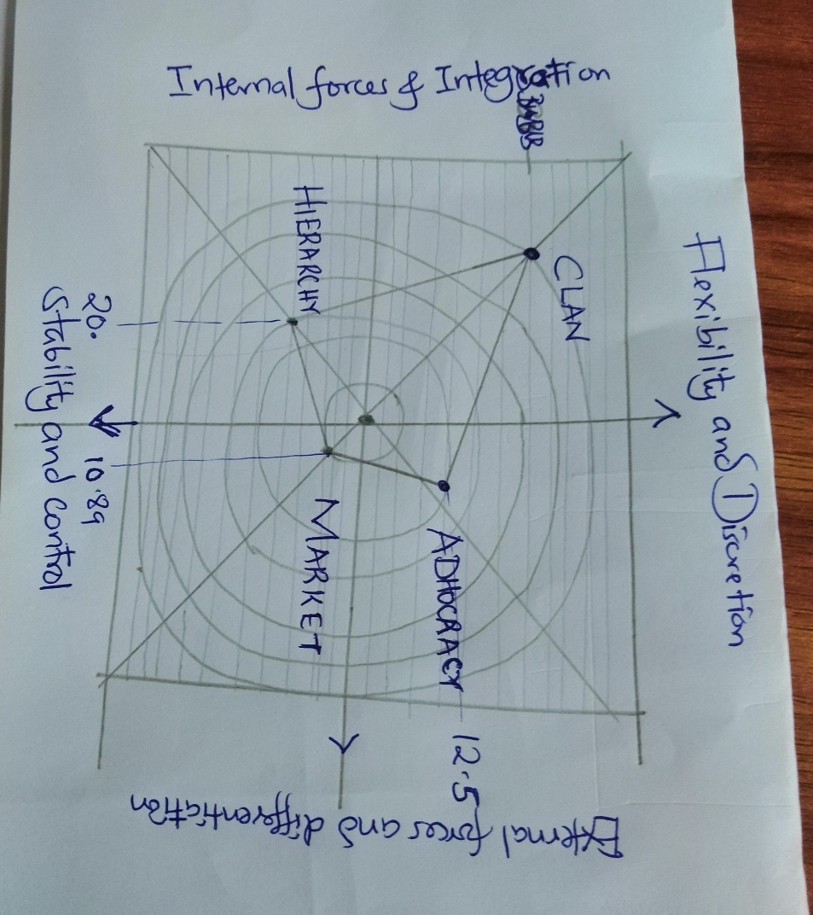
Looking at the results of the competing values worksheet, I think my results are a reflection of my organization’s overall effectiveness. The reason behind this is that considering the results, they show that our company has adopted the collaboration organization structure. According to my experience in the company, this is very true since the people prefer having processes, purposes as well as cooperation that bring about collaboration in the organization (Heritage, Pollock, & Roberts, 2014). Therefore, if the results can quickly reveal these results from the culture by looking into various factors, then, I believe the model results show the overall effectiveness of the organization.
I think our organization's leadership can use this tool to diagnose any cultural issues that might be present in the organization. The fundamental reason behind this is that the analysis tool is very dynamic. The analysis tool is dynamic since it can show where the company gives less concentration in yet very critical. Also, the analysis tool stretches to include some other factors that determine the behavior of our graph. One of them is external focus and differentiation (Cameron & Quinn, 2011). Here, maybe the company claims that it focusses on the external differentiation, but in the real sense, they don't, the company can realize this and employ the necessary strategies to go the direction it should go.
According to the assessment I have done regarding my organization’s viewpoint of its culture, it shows some forms of values contradiction as well as the ethical dilemmas. It opened to me that some leaders were advancing some values which do not feature in those that the organization's culture promotes. As long as I know, these leaders seem not to be aware of our organizational culture. Often, this happens to a leader if they do not take their time to study the organization keenly and understand its culture.

References
Cameron, K. S., & Quinn, R. E. (2011). Diagnosing and changing organizational culture: Based on the competing values framework. John Wiley & Sons.
Heritage, B., Pollock, C., & Roberts, L. (2014). Validation of the organizational culture assessment instrument. PloS one, 9(3), e92879.

